BIT 4107-Mobile Application Development
ENHANCED PROFESSIONAL STUDENT LOGBOOK
Student name: ANN ITOTIAH
Admission Number: BIT/2024/ 54209
School/Faculty: COMPUTING AND INFORMATICS
Programme :
Academic Year: THREE
Semester: TWO
Lecturer: MICHAEL NYORO
Phone Number:0718822722

WEEK 1: INTRODUCTION TO MOBILE APPLICATION DEVELOPMENT
TOOLS AND SOFTWARE USED
Android Studio
VS Code
Flutter SDK
Dart
Android Phone

PERSONAL REFLECTION
During my project development, I used VS Code, Android Studio, Flutter SDK, Dart, and an Android phone to build and test my application.

VS Code was my main coding tool because it is fast, simple, and supports Flutter development well.
Android Studio was mainly used for the emulator and debugging, which helped me test the app on virtual devices.

The Flutter SDK allowed me to build a cross-platform mobile app using a single codebase, while Dart was the programming language used to write the app’s logic and structure.

Finally, I used an Android phone for real testing, which helped me see how the app performs in real-life conditions.

Overall, these tools worked well together and helped me successfully develop and test my project while improving my mobile app development skills.

WEEK 2: MOBILE DEVELOPMENT ENVIRONMENT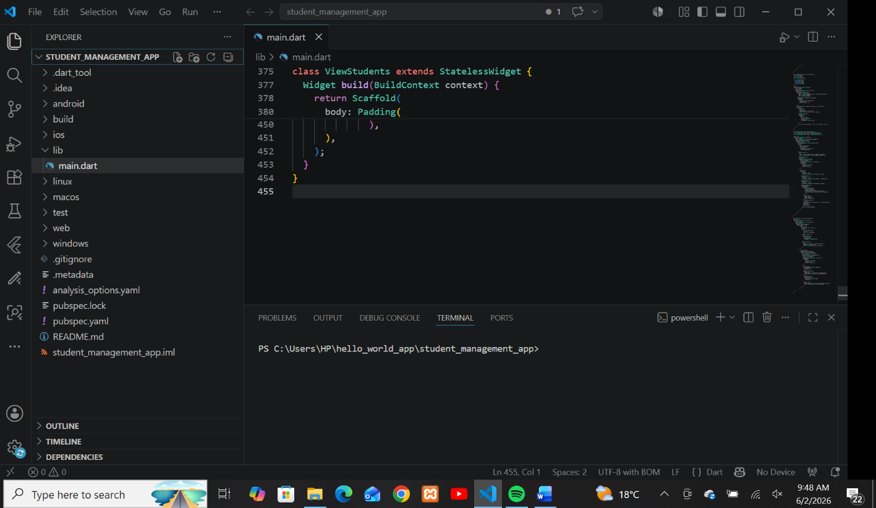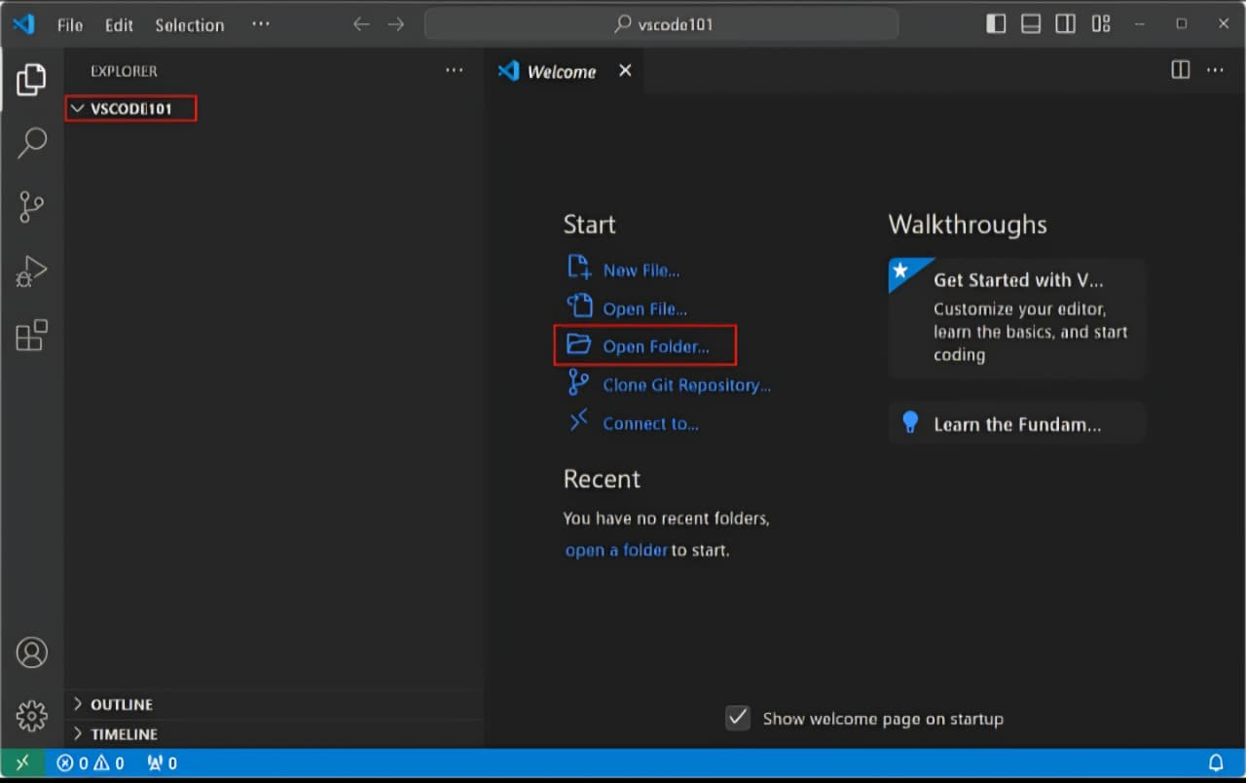
PERSONAL REFLECTION

Developing a mobile application was a valuable learning experience that helped me understand how real-world apps are built. I used tools such as **VS Code, Android Studio, Flutter SDK, and Dart**, along with an **Android phone for testing**.

Through this project, I learned how to design user interfaces, write functional code, and connect different parts of an application together. Flutter made it easier to build a cross-platform app using one codebase, while Dart helped me structure the logic clearly.

I also learned the importance of testing, especially on a real device, because it helped me identify issues that were not visible in the emulator. Using GitHub also taught me how developers save and manage their work professionally.

Overall, this project improved my technical skills, problem-solving ability, and understanding of mobile app development from design to deployment.

WEEK 3: USER INTERFACE DESIGN
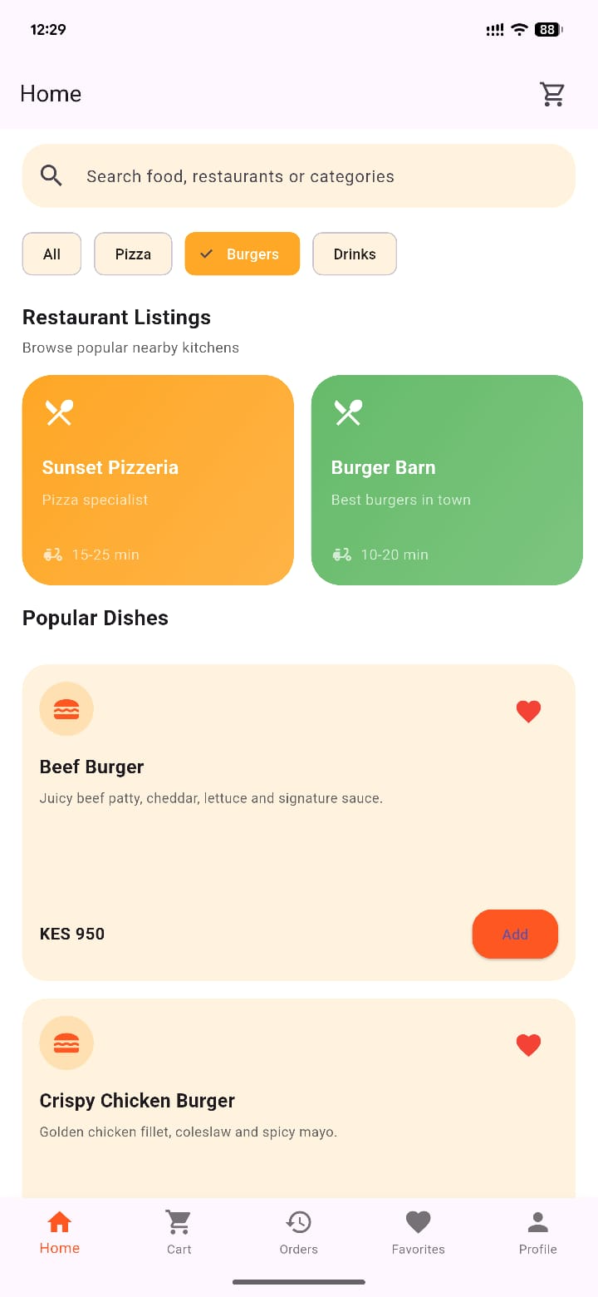
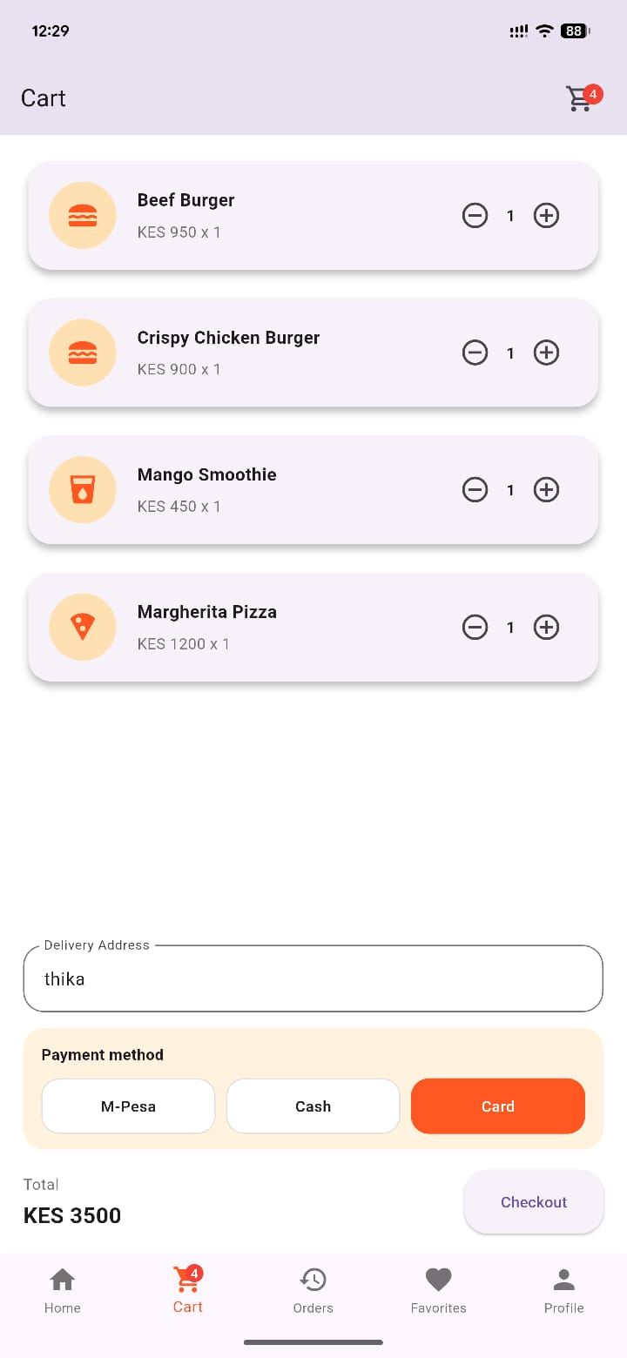
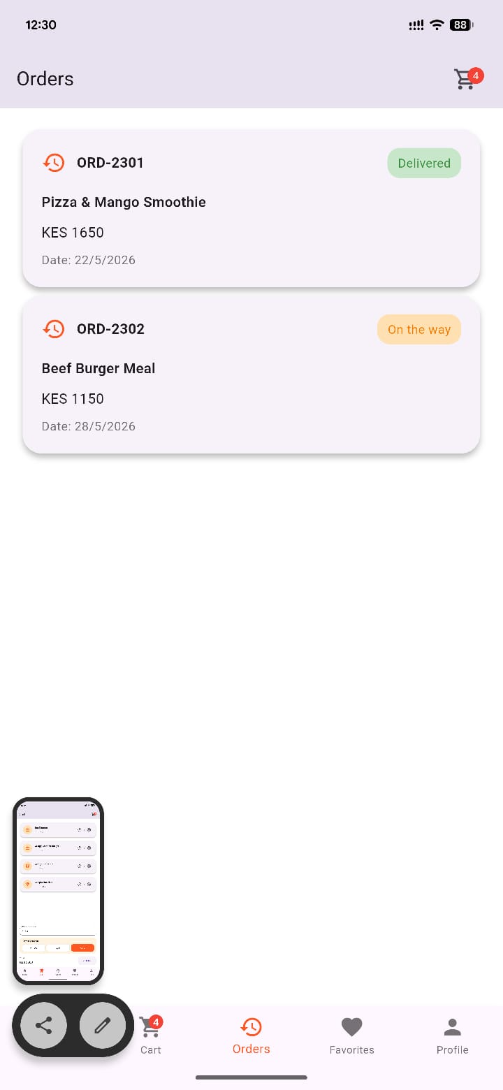
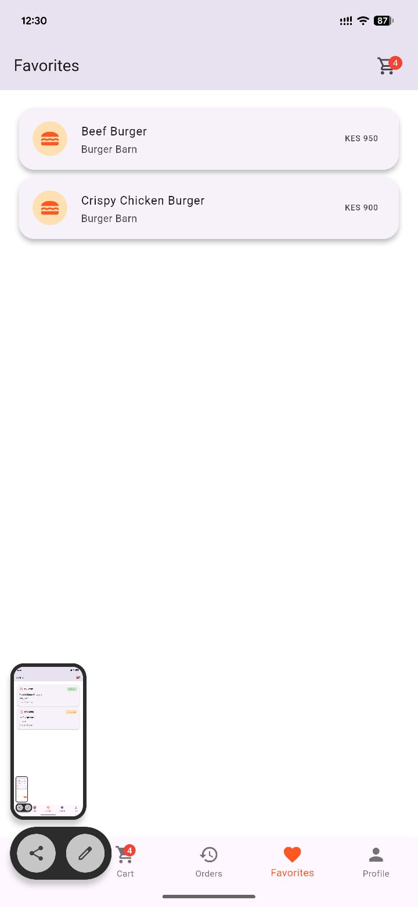

Personal reflection
I focused on user interface design for the Food delivery app using Figma. I learned how to create and organize screens, design user-friendly layouts, and improve overall system usability. This improved my understanding of UI/UX principles and enhanced my design skills.
Week 4: Event handling and user interaction




Personal reflection
I learned about event handling and user interaction in the food delivery app . I implemented how users interact with the system through buttons, forms, and input fields. This improved my understanding of how applications respond to user actions and enhanced my programming skills.
Week 5: Data management

Personal reflection
I focused on data management in the food delivery App. I learned how to store, retrieve, update and request information using local storage and databases. The app helps me interact with the customer and even know their personal favorites meal. This improved my understanding of how data is handled efficiently and enhanced my skills in managing application data.

